

**Hedge Funds and Financial Stability**

Speech given by

Sir John Gieve, Deputy Governor, Bank of England

At the HEDGE 2006 Conference 17 October 2006

1

All speeches are available online at [www.bankofengland.co.uk/publications/Pages/speeches/default.aspx](http://www.bankofengland.co.uk/publications/Pages/speeches/default.aspx)

# HEDGE FUNDS AND FINANCIAL STABILITY

**Introduction**

Hedge funds get a bad press. They often appear as the latest in a long line of financial demons - from the “gnomes of Zurich” whom Harold Wilson blamed for the pressure on the pound in the 1960s, the asset strippers and property tycoons of the 70s, Gordon Gekko and the “liar’s poker” players of the trading floors of the late 80s, and Harry Enfield’s “loadsamoney” lads of the 90s. The phrase “hedge fund” can conjure up an image of secrecy, million dollar bonuses, and the mysterious world of mathematical models and offshore havens. On top of that they are often presented as a threat to financial stability and thus to the savings and prospects of “real” workers.

But despite, or possibly with the help, of this commentary, assets managed by hedge funds have continued to grow strongly. They have moved on from being the province of rich professional investors to collecting an increasing share of institutional funding. They may still have only a small proportion of total assets under management but they are growing fast and their leverage and active trading strategies make them very influential in many markets – traditionally in equities, but more recently in new structured credit markets. And of course, while they may be worried by the growth of hedge funds and modern financial markets, most other cities and countries are deeply envious of London’s place as the location of choice of such a high proportion of hedge fund managers.

So I’m pleased to have the opportunity today to set out our assessment of how the growth of hedge funds is affecting the financial system and risks to financial stability.

# Hedge fund industry

But I’d like to start with the question why – why have hedge funds grown so rapidly in the last few years? After all they have been around since Alfred Winslow Jones set up the first long short

equities fund in 1949 and there has been a steady development of the sector over the intervening decades with a growing variety of styles, strategies, sizes and status; hedge funds are like a family

– you can see the resemblance without finding a single common feature. But the recent growth of the hedge fund sector has been explosive (Chart 1) with assets growing from around $200 billion in 1998 to about $1¼ trillion today.1

Part of the answer is the growing power of technology and financial theory to unpack traditional investment products, like equities and bonds, into their component parts and then sell them separately or in new bundles which may appeal to particular groups of investors. This has increased the opportunities for specialisation. So the growth of hedge funds is one aspect of the technological revolution which is also transforming the structure of other industries from manufacturing to entertainment.

The technology has allowed a ferment of financial innovation and put a huge value on the relatively few people who can understand and handle the growing complexity of markets. It is no surprise therefore that some of those people have seized the opportunity to take the rewards of ownership by setting up on their own. This was perhaps encouraged in the early days by the fact that the expertise lay mainly on the trading sides of the banks on the other side of the Chinese walls from the investment managers. The hedge funds are something of an investment bank diaspora.

Of course the banks are responding to the loss of key staff and expertise by establishing their own internal hedge funds or adding hedge funds to the range of investments offered by their asset management activities. They have the resources and breadth and depth of market penetration to be formidable competitors to the independent funds as asset managers. On the other side of course, in their role as prime brokers, the investment banks have benefited hugely in terms of fees, interest and the trading income generated by the active management of hedge fund portfolios. It will be interesting to see how the balance shifts in the coming years. I would be surprised not to see a rationalisation into a smaller number of large, independent funds with a shift of business back into the big institutions as the new markets and products become more familiar. This is what we have seen elsewhere in the financial sector and in other industries.

# Hedge fund performance

1 Note that Chart 1 does not cover the entire hedge fund industry.

Finally, of course, hedge funds have been growing because they have offered attractive returns at a time when there has been a search for yield across the major markets and when, partly as a result of the greater sophistication of capital markets, long yields in particular have been low worldwide.

At risk of some caricature, it seems to me that the sector has been using two rather different sales pitches.

One is the offer which matches the name: the claim that funds can provide average returns comparable with those of an index but without the index’s volatility.

Chart 2 seems to provide some support for this. It shows if you had placed money with a representative group of hedge funds in 1994, regularly switching your allocation across different hedge funds exactly to follow that of the sectoral composition, you would have matched the cumulative appreciation of the world equity index but in a way that largely avoided the collapse in equity prices in 2000-02. So the risk-adjusted rate of return, even net of the fees, may have been higher. I should caution that this analysis ignores the survivorship and other biases associated with the construction of hedge fund indices so getting this ideal result would have been much harder than it looks.

More recently the emphasis has been on the ability of hedge funds to achieve ‘alpha’.2 This is a braver claim and the record is less clear. The position of hedge funds may have been aided by the restrictions on the types of product that can be marketed to retail investors. In that sense, while the derivative markets are highly competitive they have not been completely free and there may have been a premium for hedge funds and their professional investors.

But for the longer term, I must admit I am a sceptic. While a few investors or funds can consistently beat the markets, there seem reasons to doubt whether the whole sector can deliver superior risk-adjusted returns, especially as the rest of the market catches up with the financial innovations they have led and as they grow to become much more than marginal players.

2 The abnormal rate of return in excess of what would be predicted by an equilibrium model like the Capital Asset Pricing Model.

Indeed, this search for investors’ Holy Grail may go some way to account for the surge in births and closures among hedge funds with, according to Hedge Fund Research, over 2,600 new starts since the beginning of 2005 but with nearly 1,100 closures, double the rate of 2004.

# The impact of hedge funds on the financial system

What does the growth of the hedge fund sector mean for the stability of the financial system?

In the Bank’s last *Financial Stability Report* in July we identified six main sources of vulnerability in the financial system and the growth of hedge funds was not one of them – nor, I believe, would it have been in the next six. That doesn’t mean they are not important. They are mentioned 40 times in the Report. And our Market Intelligence function has developed regular and frequent contacts with several of the large funds and many of the prime brokers in London, the US and Asia – and we are very grateful for the time they give us.

From a systemic point of view what matters is the wider change hedge funds are part of and the different incentives and behaviour to which that gives rise. In many ways the growth of hedge funds and the derivative markets they feed off is part of a shift from bilateral negotiated banking finance to arms length finance through asset markets.

In the long term, that shift should be good for stability. What has traditionally worried central banks and regulators most is the risk that the key intermediaries at the centre of the financial system – especially the big banks – may fail in a way that sends shock waves throughout the system and damages the wider economy. The development of more sophisticated markets which allow these key players to transfer some of the risk that they have traditionally held on their own balance sheets is positive for the system as a whole. And what better place to put it than in a large number of independent funds financed by very rich individuals and professional investors, whose losses are of interest only to themselves, and in long term investment institutions with highly diversified portfolios?

It is important always when assessing risks from a change in financial markets to remember the risks in the *status quo*. And the traditional world of vanilla products and national markets was not a haven of stability. In the early 1970s, for example, a surge of highly-leveraged property investment was channelled through the UK’s fringe banking sector. When their over-leveraged bets on real estate came to grief because of unexpected increases in interest rates, the large UK clearers had to step in through a Bank of England organised ‘lifeboat’ which amounted at its peak to about 40% of the large UK clearing banks’ capital.

The active trading of hedge funds makes markets more liquid and facilitates genuine hedging activity by others – including systemically important banks. Increasingly, hedge funds – led by those managed from London - have become an important part of the risk transfer process, providing liquidity to evolving structured derivative markets. So hedge funds have been positive for market efficiency. And in recent episodes of market stress – the autumn of 2003 and the spring of last year – some have helped provide liquidity to markets, enabling large banks and other investors to adjust their positions.

Of course at times of turbulence we have seen some hedge funds taking losses and facing liquidity difficulties, but we have also seen other funds stepping in to pick up the assets as prices fall and thus to provide liquidity to the market. If we face a financial crisis in the next few years we are almost bound to find some hedge funds at or near the centre of it; equally we should expect hedge funds to play a part in providing the solution.

To complete the upside story, funds have not just been a source of financial innovation but some have been pioneers in risk management and have helped make the industry more resilient – for example through participation in the Corrigan Group.

# Challenges to systemic stability

But if the growth of hedge funds is part of a helpful structural shift in the long term, any major change brings transitional risks and problems. Periods of rapid growth and innovation in financial markets have often led to difficulties and overshooting and we should not assume that this one will be different.

The LTCM episode of course demonstrated the risks. The problems in a large and exceptionally highly-leveraged hedge fund threatened widespread market dislocation and large losses for other institutions. The fund flipped from being a liquidity provider to a liquidity demander.

A great deal has changed since then of course. The sophistication of the risk controls in prime brokers and in many hedge funds has been hugely improved, and 1998 and the collapse of the high tech stock prices in 2000 form part of regular stress tests throughout the financial sector. Recent events suggest that the financial system may genuinely have become more resilient.

It would be difficult to speak about hedge funds at the moment without referring to Amaranth. What should we make of the fact that this fund incurred enormous losses and yet left markets largely unmoved? Can we put the apparently limited collateral damage down to much improved counterparty risk management since 1998? Or were we just lucky?

I suspect the answer is a bit of both. I don’t have full details of what went wrong or how much the fund’s several prime brokers knew about the fund’s overall exposure and leverage. But while Amaranth had leveraged up, it had not done so - or been allowed to do so - on the scale seen at LTCM and that lower leverage has been seen across the market (Chart 3). The fund was able to meet its margin obligations without dislocating markets and other players were willing to step in and liquidate its positions – albeit on terms which shocked the Amaranth management.

Incidentally that shock at the way markets moved so aggressively against their positions was a common feature of LTCM and Amaranth’s experience and it is an example of a trend which is not peculiar to the financial sector. In the past a failing firm could hope to get its bankers into a room and persuade them to put in more money or allow time for recovery (as the saying went, if I lose £1000s it’s a problem for me, if I lose £1billions it’s a problem for you). I suspect those times are going: firms often don’t know now who holds their shares and debt and many investors are looking to take the hit and get out as quickly as possible. This is a more brutal world to fail in.

But another key difference from LTCM was that the market event that appears to have undone Amaranth – a fall in natural gas futures prices – could otherwise be considered a benign one for growth and inflation. In that respect it was very different from 1998 when Russia’s default sent a

shock through a wide range of markets. So while we can take some comfort from the fact that losses from Amaranth were limited by improvements in counterparty risk management, we should not conclude that it will be as smooth and easy next time – and of course there will be a next time.

The fact is the fantastic growth of derivative markets and hedge funds of the last few years has taken place in benign times. The resilience of the valuations, the diversification of portfolios, the depth of liquidity, and firms’ risk management has not been tested by a severe shock.

Our FSR identified the risk that the business pressure to maintain or establish market share in rapidly expanding markets might drive companies to take on more risk than they should. There is no reason to change that assessment now. Indeed, after a short pause in May and June, we have seen the return of aggressive risk taking in many financial markets this autumn. There must be a danger that the search for yield is driving many investors into similar trades (or trades which would become closely correlated in a crisis) and that risk models are giving too much weight to the low volatility of recent times. For example, it is possible that positions are being built up, or only partially hedged, on the assumption that currently compressed corporate credit spreads will adjust moderately or smoothly. Chart 4 shows that corporate high-yield markets have not behaved in this benign way in the past.

But I should not end on a gloomy note. Working closely together, the authorities – which in the UK means the FSA, Bank and Treasury – are aware of these risks, as are the industry. And measures to address them are being taken. The second report of the Corrigan group, unlike its predecessor, has been published to forestall, rather than as a reaction to, a crisis. The rating agencies are beginning to publish operational risk ratings for hedge funds and managers.

Complementing these industry initiatives, the FSA has been developing its approach to the regulation of hedge fund managers. It has set up a special unit to supervise hedge fund managers and ensure they are subject to the same standards of market conduct, systems and controls as other asset managers and that potential conflicts of interest are addressed (for example in the area of asset valuations). It is encouraging further improvements in counterparty risk management practices by prime brokers. It has worked with the Fed in New York and the industry to significantly reduce backlogs in derivative confirmations and assignments. Its surveys of prime

brokers’ exposures to hedge funds provide an important guide to any developing concentrations or an excessive build-up of leverage. And today Andrew Shrimpton of the FSA is also here leading a business showcase session on material side letters. In these ways the FSA is seeking to ensure that proportionate regulation complements the disciplines provided by London’s large and sophisticated market.

To sum up, the rapid growth of hedge funds is one aspect of a wider transformation in financial markets. In the long term there are good reasons to see this as welcome not just in widening the range of options for investors but in promoting the stability of the financial system. In the shorter term, there are bound to be risks while the funds, other market participants and the authorities gain experience of how the new products and markets behave in a full range of trading conditions. The FSA and other authorities, including the Bank, are alive to the dangers and are doing what they can to assess and mitigate those risks.

# Chart 1

**Size of the industry (a)**

US s

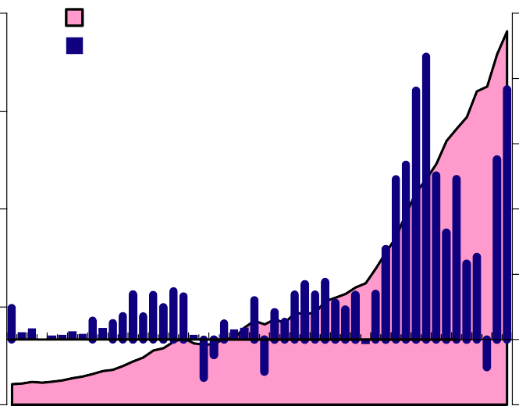

$ billions

Total AUM (LHS) Quarterly flows (RHS)

US$ billion

1,000 50

40

750

30

500 20

250

0

94 95 96 97 98 99 00 01 02 03 04

10

+ 0

-

10

05 06

Sources: Tremont Capital Management, Inc.

(a) Sample does not cover the entire industry

# Chart 2 Cumulative returns

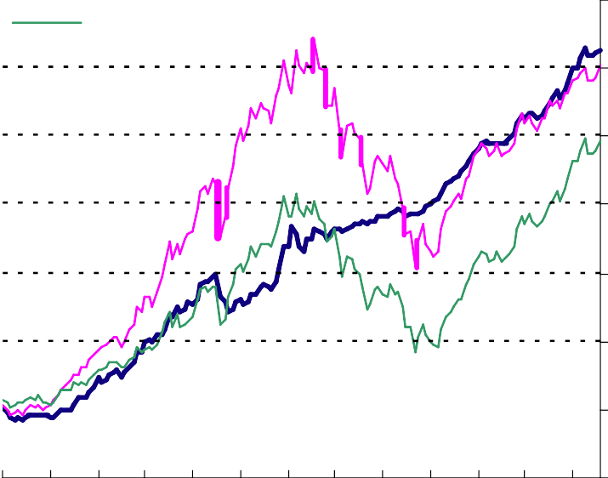CSFB/T remont hedge fund index S&P 500

FT SE All World

Per cent

300

250

200

150

100

50

0

-50

94 95 96 97 98 99 00 01 02 03 04 05 06

Sources: CSFB/Tremont, Datastream and Bank calculations

# Chart 3

**BIS indicators of hedge fund leverage**

Total leverage

Equity funds

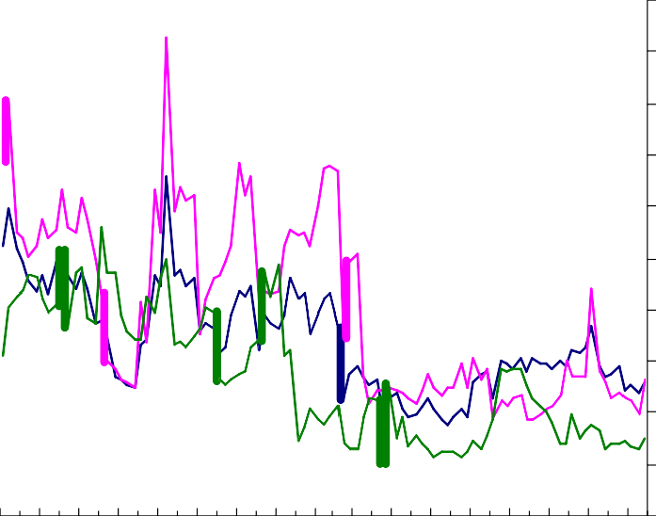Fixed Income

Level

5.0

4.5

4.0

3.5

3.0

2.5

2.0

1.5

1.0

0.5

0.0

99 01 02 03 04 05 06

98

00



1998



2000

Source: BIS.

# Chart 4

**Yield Differentials with 10-year US Treasury bond**

US Corporate Aaa US Corporate Baa

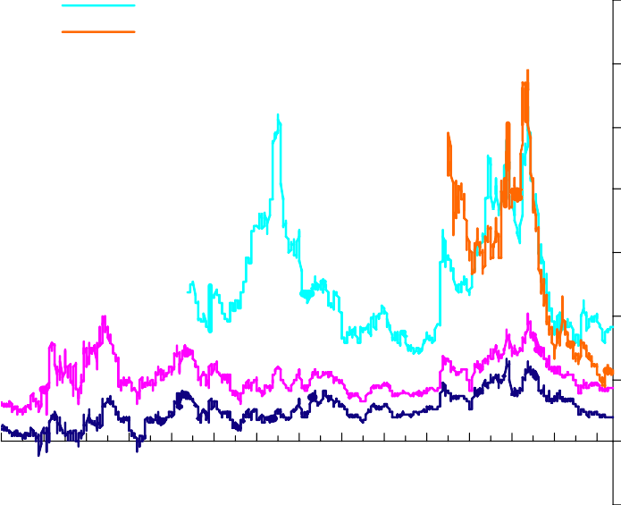US high-yield bond index (a)

Basis points

1400

EME sovereign & corporate index (b)

78 80 82 84 86 88 90 92 94 96 98 00 02 04 06

1200

1000

800

600

400

200

0

-200

Sources: Bloomberg, Merrill Lynch and Bank Calculations.

1. Monthly data until 1990, daily data thereafter. High-yield index shows the yield-to maturity rather than the effective yield.
2. Yield-to maturity.